Outdoor Spaces to Enjoy this summer in Kilkenny Hotels
The unbeatable combination of fresh air, outdoor activities and fine food is finally in our sights! As hotels prepare to open their doors for outdoor dining & activities, the start of the new ‘good times’ looks set to begin again.

Kilkenny hotels has a line- up of some outdoor dining experiences and activities that promise alfresco excellence and outdoor adventure for visitors this Summer. So, whether you’re in the mood for chic outdoor terraces, palatial pavilions or generous garden spaces, Kilkenny hotels has you covered with this great list:

Hoban Hotel Kilkenny

The Hoban Hotel’s terrace bar is a vibrant place to meet and socialise safely outdoors. Located within Kilkenny Retail Park, the hotel is just 15 minutes’ walk from the famous marble city. The newly refurbished outdoor terrace area is easily accessible from the 1801 Bar & Restaurant. Enjoy the fresh air, good food, great service and green surroundings.

Hoban Hotel Terrace

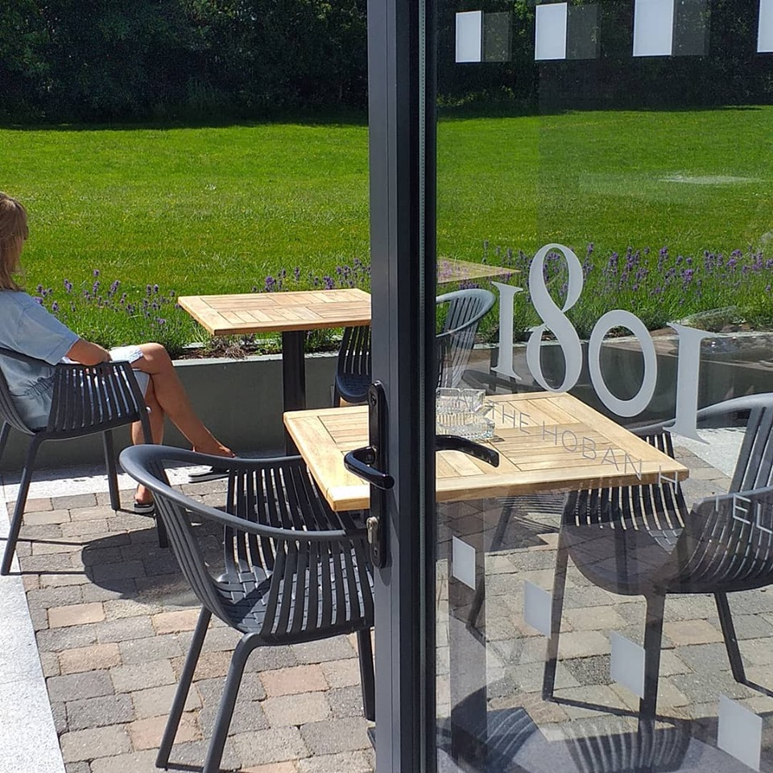

Kilkenny River Court Hotel

Located in a quiet secluded courtyard just off the main tourist area, Kilkenny’s River Court Hotel provides one of the most picturesque backdrops for outdoor dining. With a view of Kilkenny Castle and overlooking the River Nore, the Terrace at the Kilkenny River Court is the perfect place to sit back, unwind and enjoy a glass of prosecco after a day exploring the Medieval City. Whether you are on a girly getaway or couples staycation you will love soaking up the ambience in this unique location. During the day you’ll have clear blue skies surrounding the Castle but at night the river and terrace are lit up, creating a wonderful magical atmosphere.
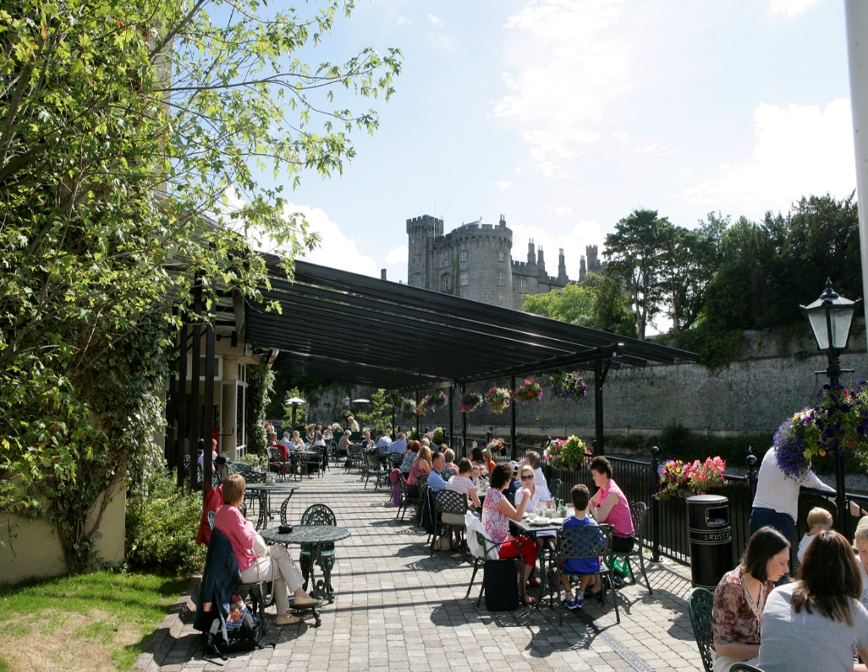
Kilkenny Inn Hotel

Located under the shadows of St. Canice’s Cathedral on the Medieval Mile, the boutique Kilkenny Inn Hotel offers an outdoor street dining area in the heart of the city. Looking out onto one of the oldest and most beautiful parts of Kilkenny City, it is the perfect place to relax, have a drink and enjoy some light bites.

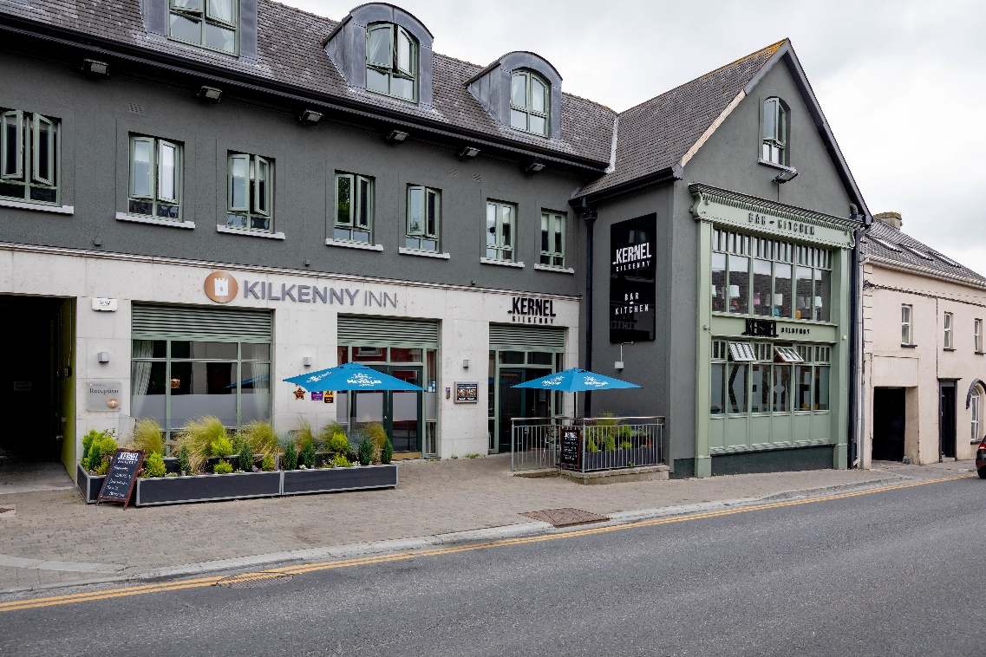.

Avalon House Hotel

Idyllically located in the picturesque Kilkenny countryside, just a short drive from Kilkenny City, Avalon House Hotel has recently refurbished it’s outdoor bar and renamed it ‘Little Jim’s’. With a clean 90’s American diner feel to it, this is the perfect spot to meet up safely and have a drink with friends or family this summer. Make a day of it and enjoy an exhilarating day at Castlecomer Discovery Park. Enjoy a woodland walk or for the more adventurous try Ireland’s longest zip line as you zip over stunning woodland, two lakes and 17th century hand-restored bridge. End your day with some well-deserved beers and Al Fresco dining at the Avalon House Hotel.

Beer Garden

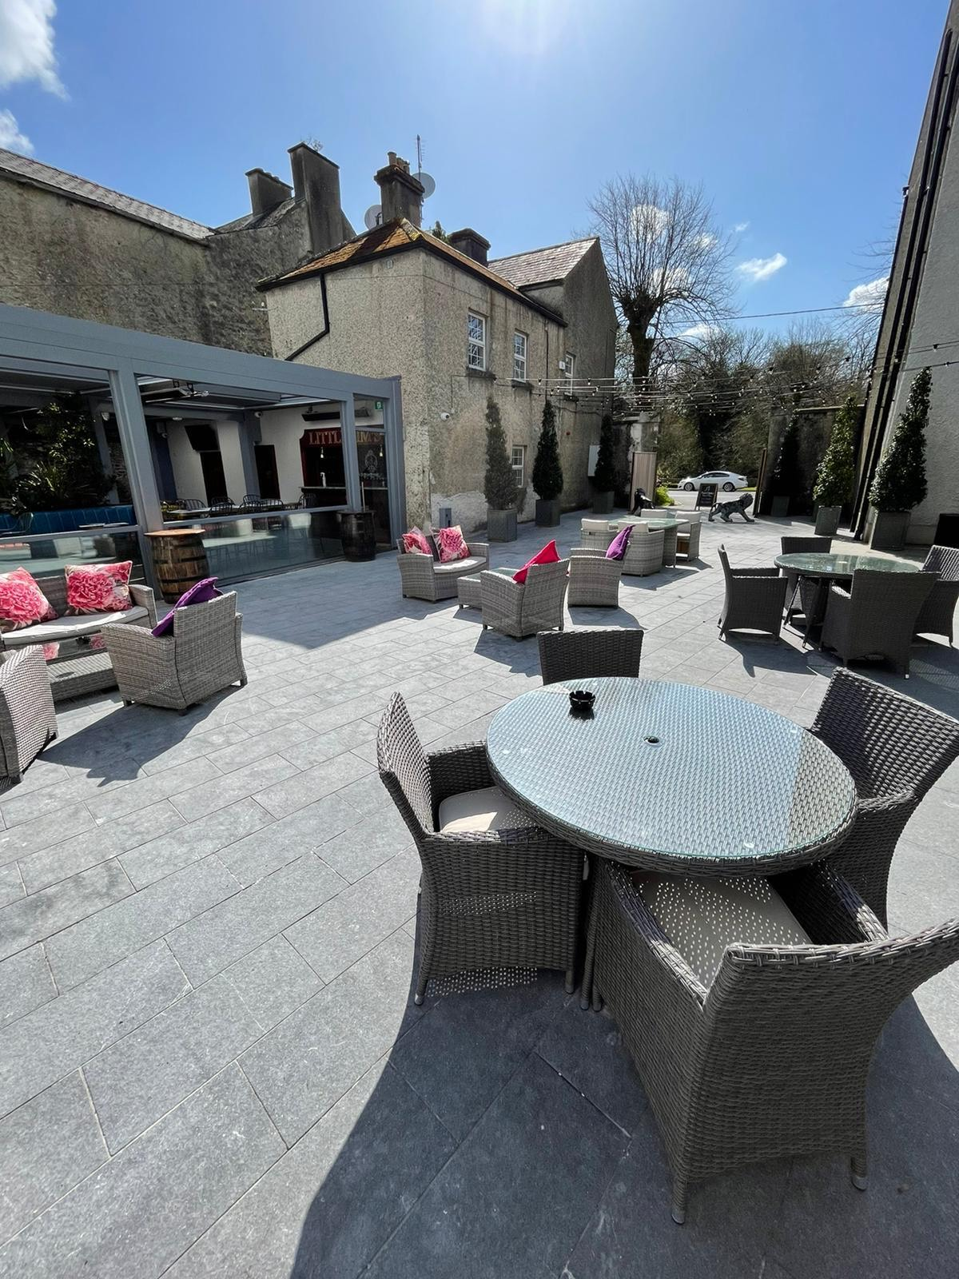

Al Fresco Dining

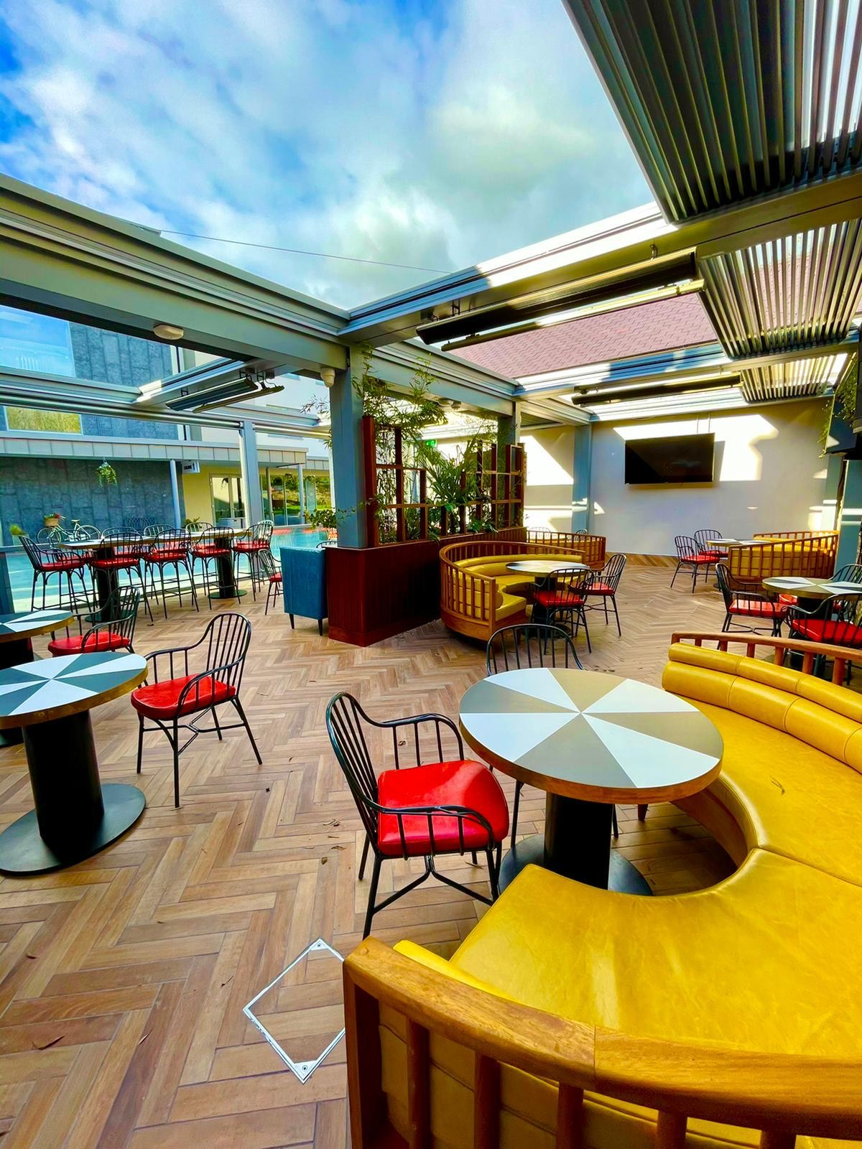
Glendine Inn
A warm welcome awaits you from the Phelan family at the Glendine Inn. Ideally located for golf (course 200m away); the railway station and the historic city of Kilkenny are only 1.5km away. Enjoy a round of golf or explore the wonderful sights in the city following by some downtime on the terrace with Al Fresco dining in the summer sunshine.

Glendine Inn Terrace
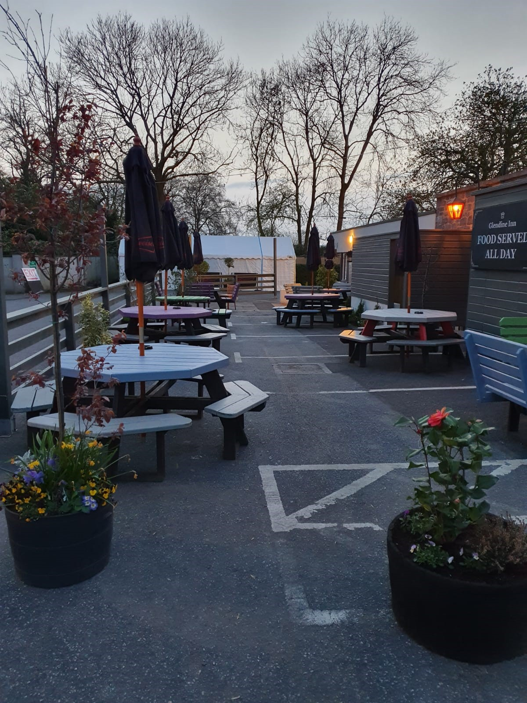
Kilkenny Ormonde Hotel

The Ormonde Hotel in Kilkenny City Centre is where a relaxed atmosphere, excellent food and a genuine welcome awaits you. The terrace bar is spacious and warm, with an outdoor fire providing the perfect backdrop to an extensive and impressive Cocktail and Drinks List.

Langton House Hotel

Langton House Hotel is an iconic hotel & bar in the medieval City. Renowned for its impeccable customer service, good wholesome cuisine and vibrant atmosphere. The hotel is centrally located on the bustling John Street at the heart of Kilkenny City Centre. At Langtons Kilkenny the award-winning main bar is a bustling hub of activity with live traditional Irish Music daily during summer months and the best of local musicians and DJ’s on the weekends. You will find bespoke cocktail menus, the best of Irish and International Beers and they are also a proud member of 'Kilkenny Whiskey Guild' with over ninety Irish whiskeys to suit all tastes! There is a wide choice Outdoor dining options. From dining to sipping on a beer in one of our many mature gardens and outside terraces they have somewhere for everyone to relax and enjoy on their Kilkenny summer staycation!

Birdies Terrace

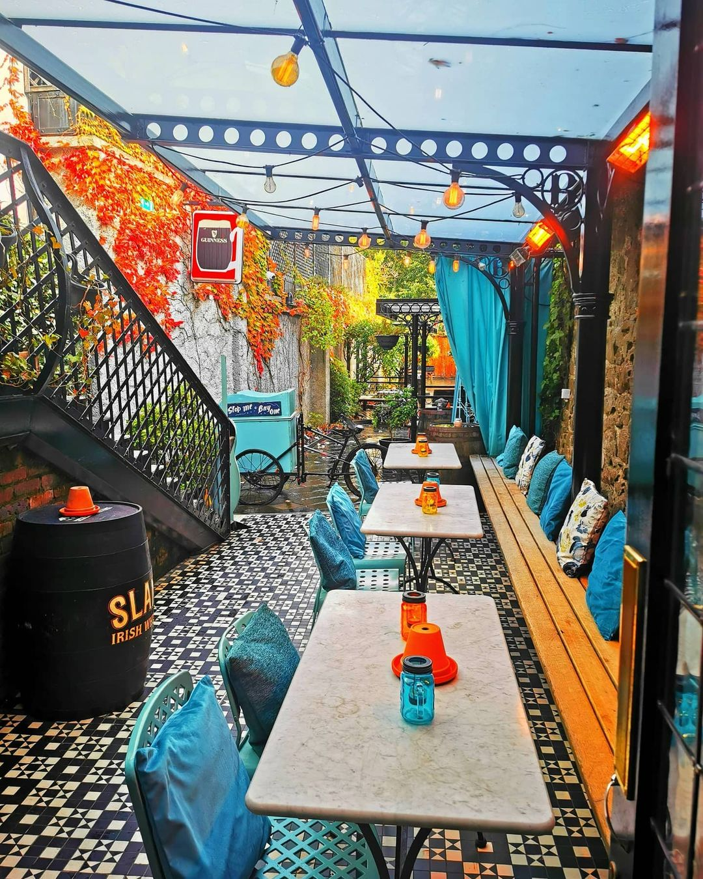
Langtons Al Fresco
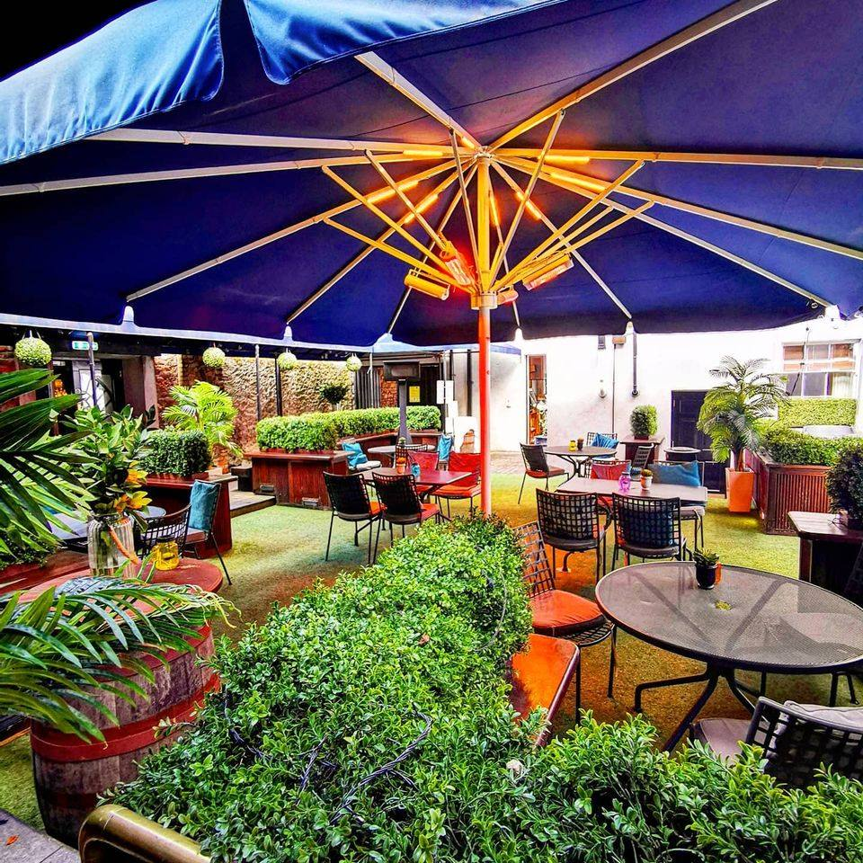

Cocktails at Langtons
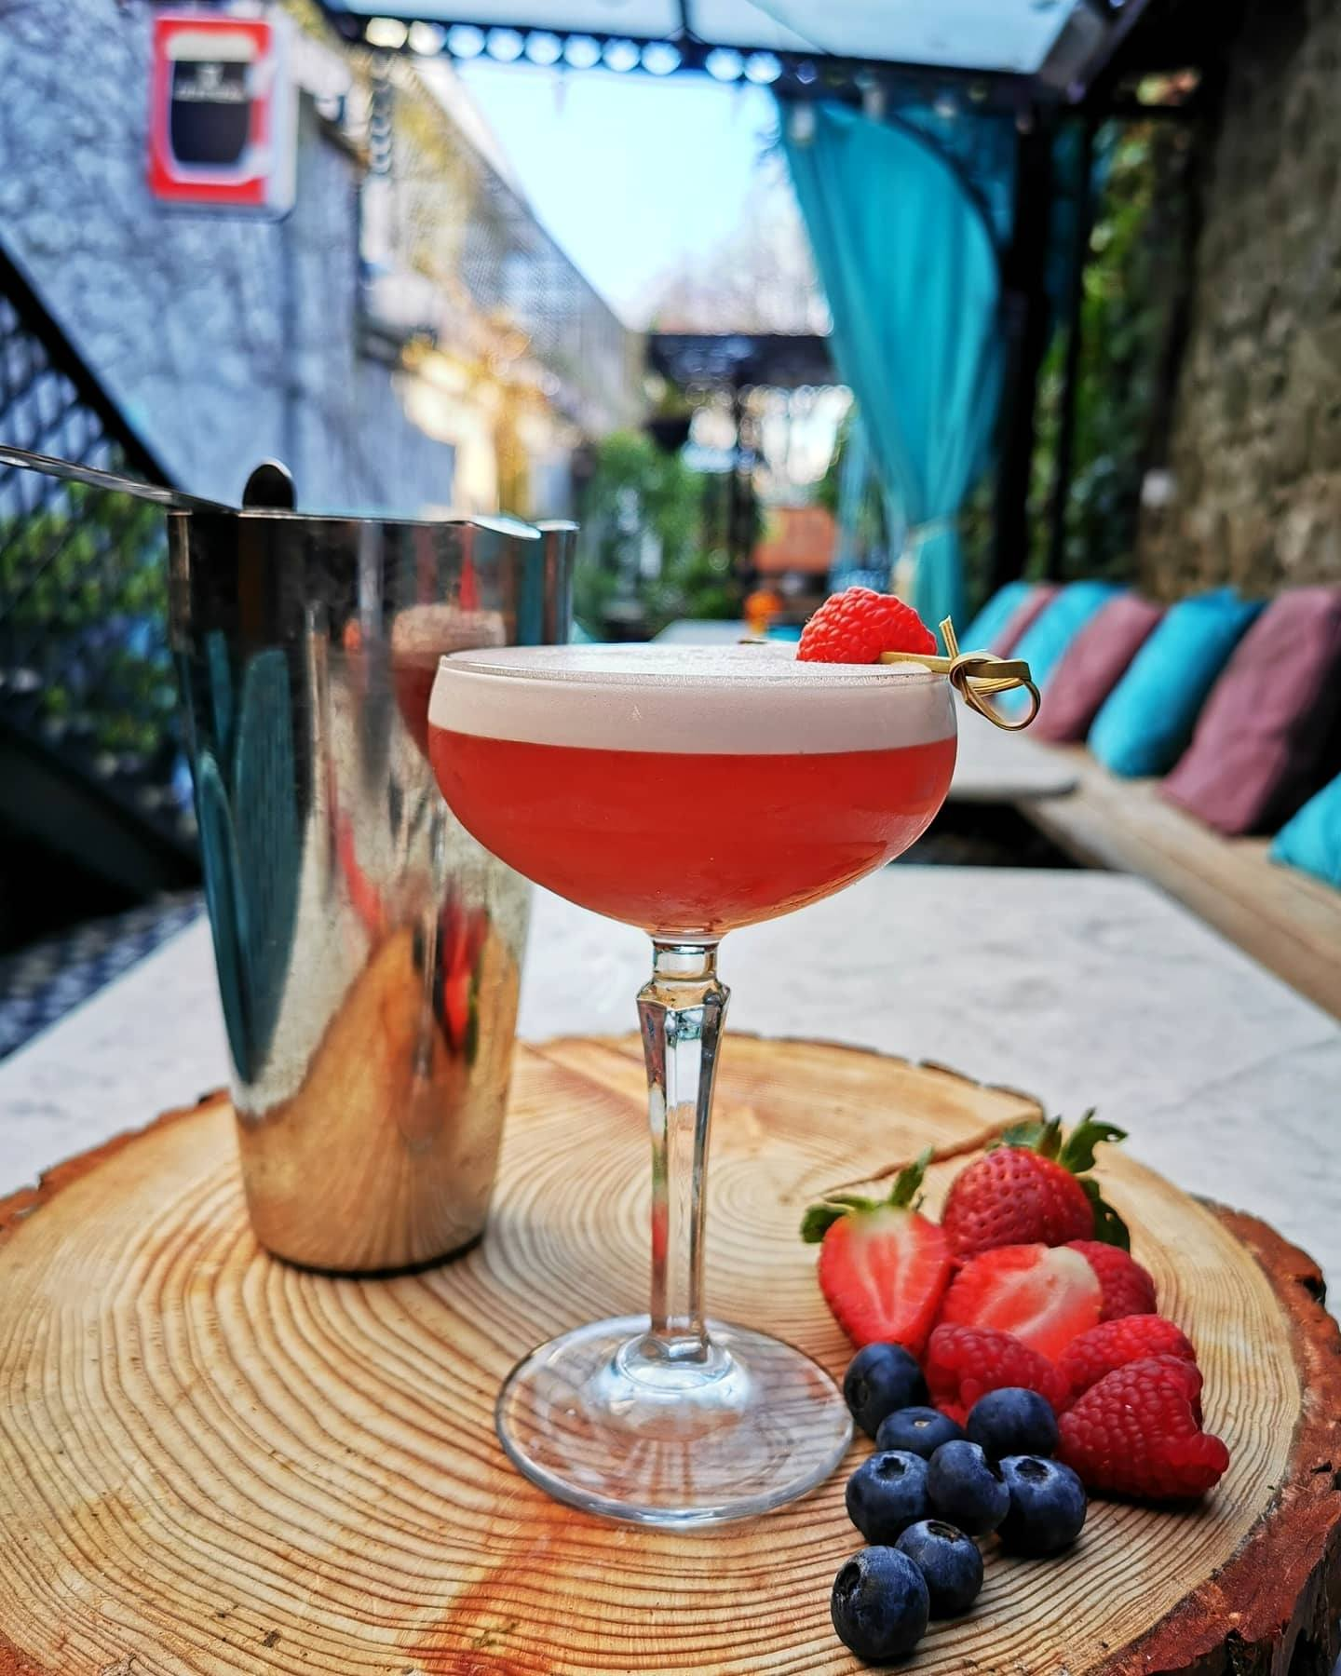

Butler House & Gardens
If you are in search of something special you have come to the right place!! Butler House and Garden is the charming Dower House of Kilkenny Castle since 1786.

This unique House in Kilkenny brings history, charm, romance and a warm welcome to all who visit. The superb location of Butler House offers visitors the very best of Kilkenny City. Through the front door, you will find Patrick Street, a two-minute walk to the centre. Through the back door, you will find the internationally renowned Butler House Walled Garden. This charming Georgian Garden was restored to its former glory in 1999 and boasts its own private entrance to the Castle yard and Kilkenny Castle. Enjoy a stroll around the gardens followed by a champagne Afternoon Tea on the terrace. It doesn’t get much better than this!

Al Fresco Afternoon Tea
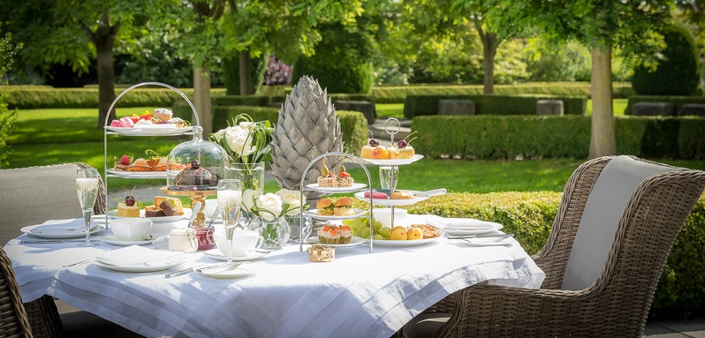
Picnic in Butler House Gardens
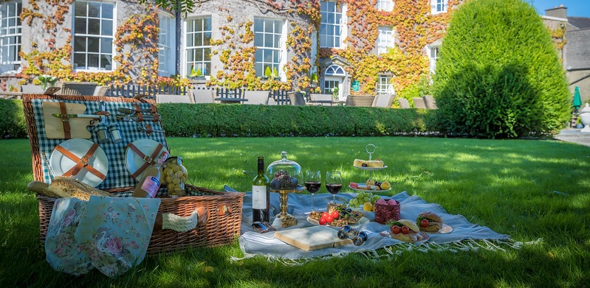
Stroll in the Gardens
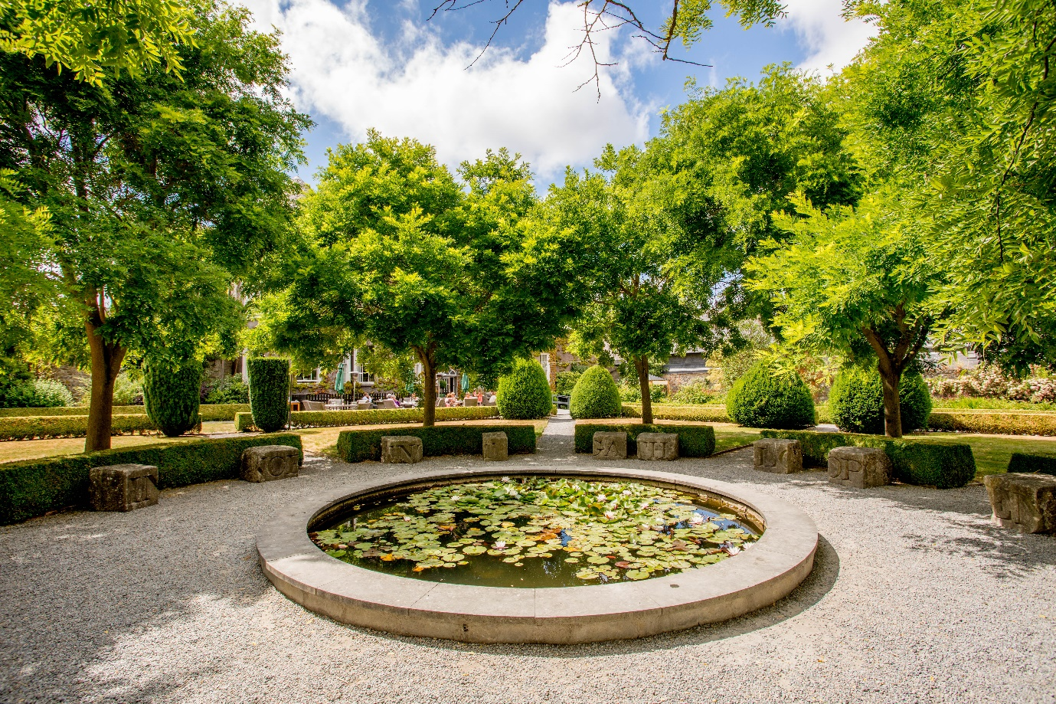

Lyrath Estate
The luxurious five star Lyrath Estate Kilkenny is unlike anywhere else. The grounds are spread across 170 acres of Irish countryside, complete with picturesque lakes, historic gardens, and emerald woodlands. You will be spoilt for choice for outdoor activities, dining and beautiful grounds to explore.
Outdoor Family Activities
Walking in the Grounds & Picnic
The Estate is home to a host of native wildlife including ducks, rabbits, hares, and squirrels. Not to forget the ancient trees, several of which are protected by preservation order. The lake, with its fine stone dam and waterfalls, is picture-perfect and a popular picnic spot for guests on a sunny day. Further afield is an elegant pond and small wooden copses dotted throughout the Estate, just waiting to be explored.
There are two signposted walks around the Estate. The first is approximately 2.5KM and the second is 5KM. There is plenty to discover and ample space to satisfy even the most adventurous
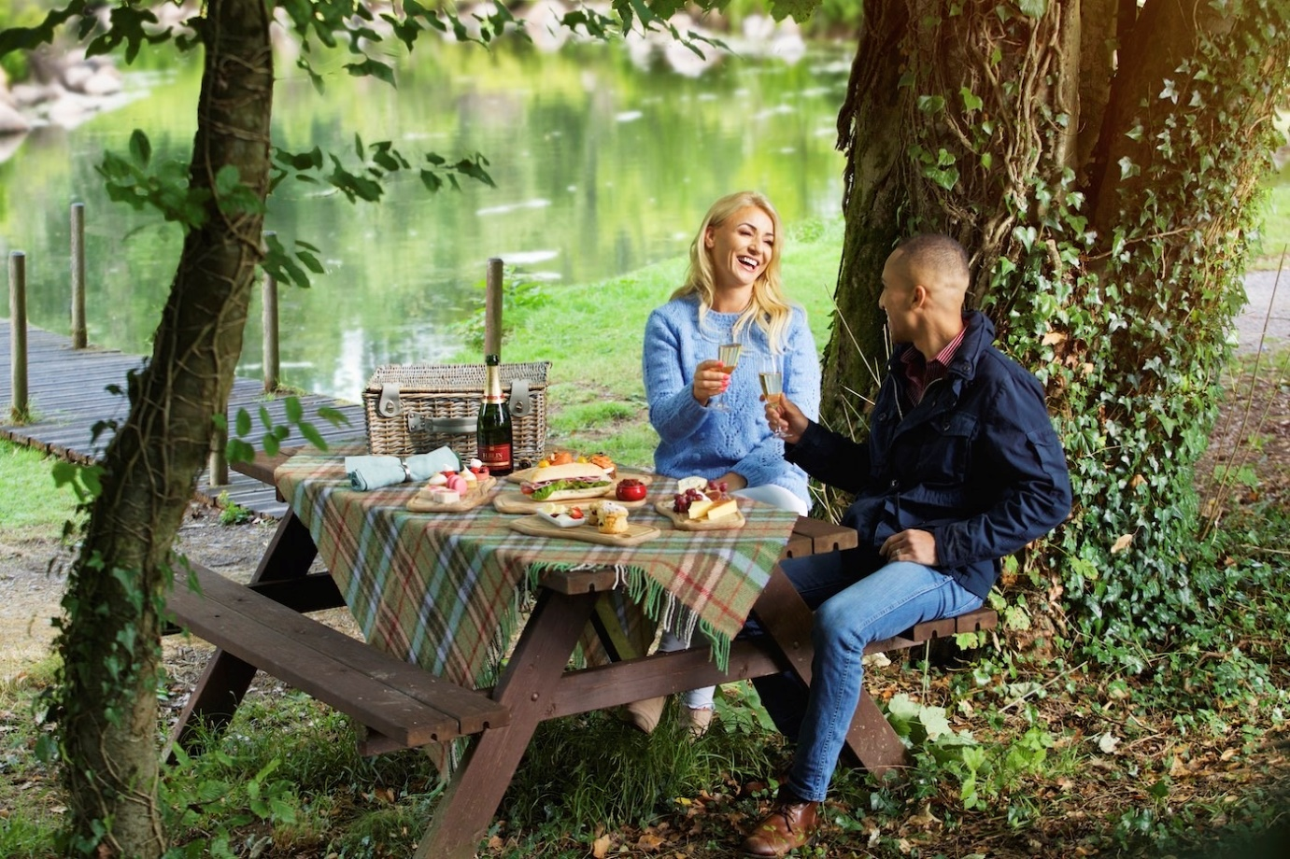

Hawkeye Falconry
Experience falconry, the Ancient Sport of Kings, with Hawkeye Falconry on the Estate. You will have the opportunity to hold and examine these exquisite creatures up close and learn how to beckon the hawk to return to you after it has departed for the trees. You will set off for your Hawk Walk with a Falconer. Here, you will take primary control of the hawk, calling it to your gloved forearm. An experience all ages will enjoy
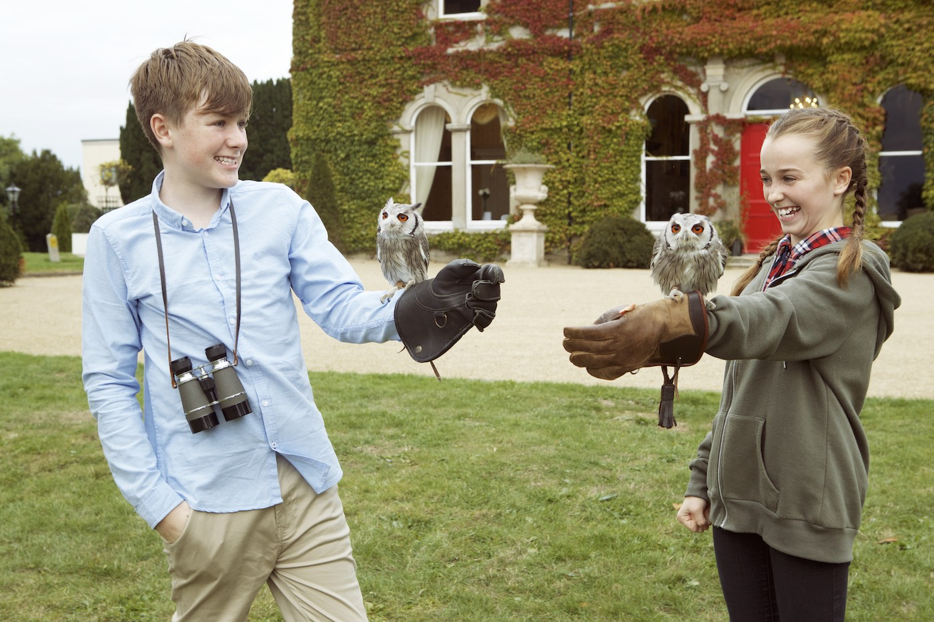
Archery
Archers of all ages and abilities are welcome , from ten years and up. Children must be accompanied by an adult. Trained expert, Robert McPartlan, is on hand to talk beginner through the basics and offer up tips and tricks for the more experienced.
Pavillion BBQ
The BBQ Pavilion at Lyrath Estate has become one of the most sought-after outdoor venues in Kilkenny since it opened in 2018. The unique venue is perfect for corporate BBQs, and private family celebrations. Immerse yourself in the great outdoors while satisfying your appetite with a mouth-watering barbecue.
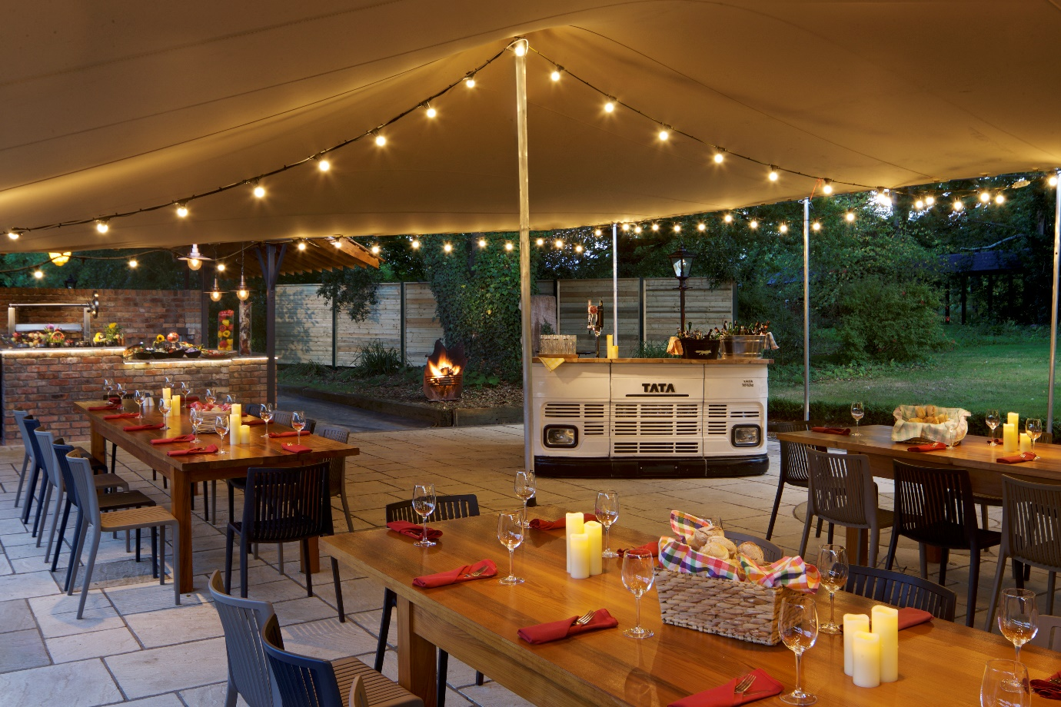

Al Fresco Dining on the Terrace
After an action packed fun-filled day enjoy an ice cold glass of Sauvignon on the Lyrath Terrace
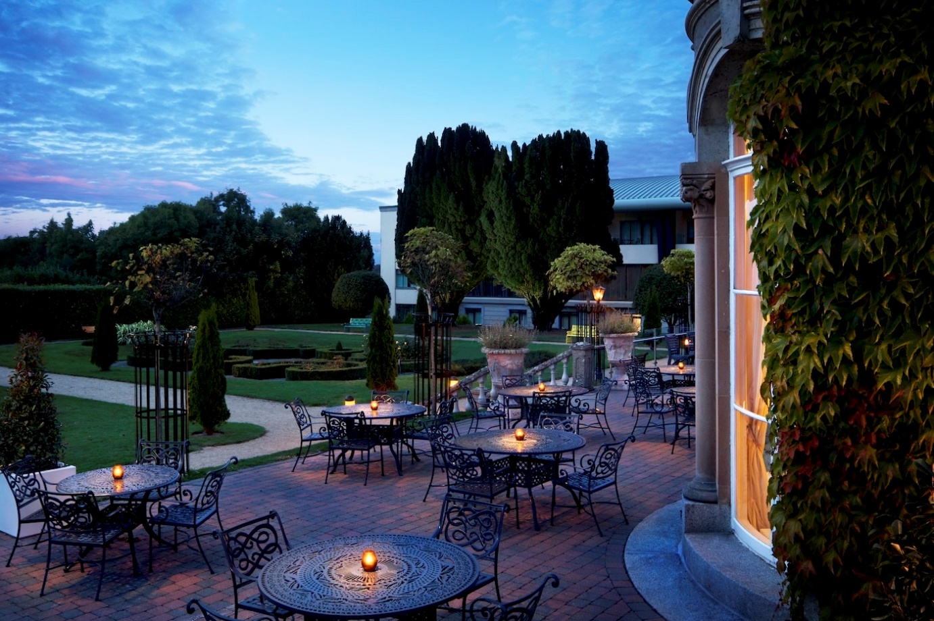
Cycling
What better way to explore the grounds at Lyrath Estate than on two wheels. Enjoy a romantic bicycle ride before dinner.
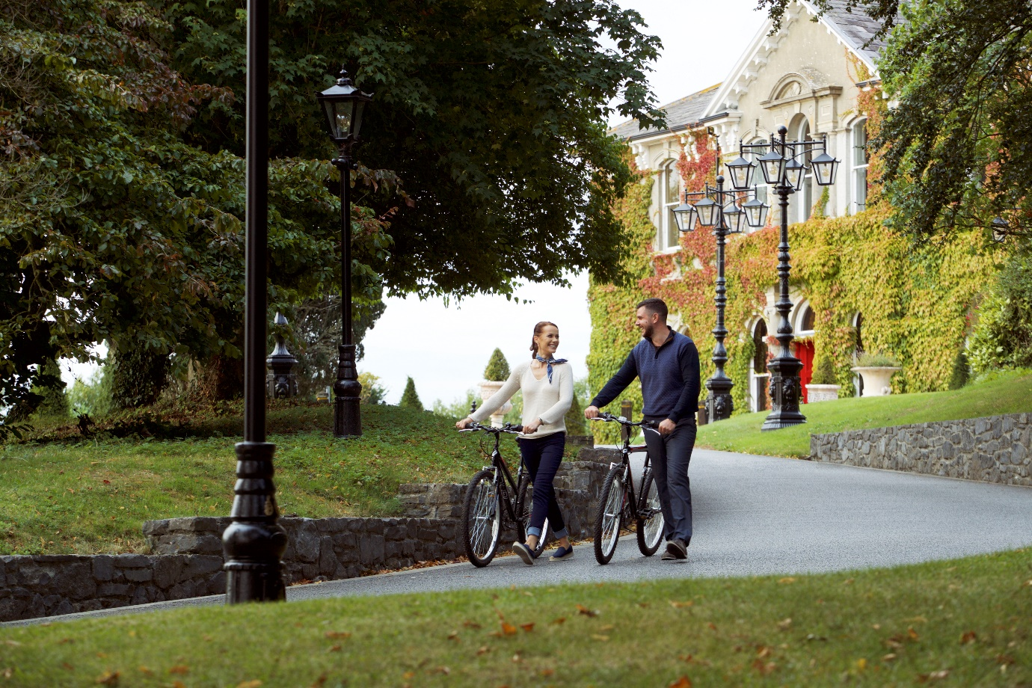

Mount Juliet Estate
There is a legacy to the Mount Juliet experience that stretches far beyond the luxury of the bedrooms and the decadence of the dining options. Perhaps you feel the urge to thunder through open pastures and traipse across woodland trails on horseback. Maybe you want to feel the tug on your line and the splash from the River Nore as a salmon takes your bait. And have you ever felt the singular rush of an arrow flying forth from your bow or a falcon swooping down to land at your command?
Discover the unique range of activities on the estate, unparalleled in the way they combine deep-seated historical traditions with the best modern equipment and practices.
ENJOY THE 500 ACRES ON THE ESTATE

Walking and Running Trails
There are many walking and running trails within the 500 acres on the estate to enjoy. Estate maps are available at reception.

Treasure Hunts
Discover the highlights of the wonderful estate in a fun-filled Treasure hunt on the picturesque grounds by those who know the estate best.

Biking Trails
Complimentary bike hire is available from reception to explore and spend time in our wonderful surroundings.

Playground
There is an Outdoor playground to enjoy with your children on the estate. Open from 8 am daily. Complete with Zipwire, swings, and slide. This is the perfect place for fun.

Yoga
Morning yoga classes on the lawn can be booked at reception.

Al Fresco Dining on the Estate
Picnics
What finer way to enjoy the wonderful estate than a private lunch outdoors. Mount Juliet will assemble a bespoke gourmet hamper that meets your requirements and dietary needs, which you can share with your loved one, creating new memories at Mount Juliet Estate

Equastrian
Whether you’re an experienced rider wanting to emulate Lady Helen McCalmont, a keen horsewoman, or you’re a complete beginner looking to experience an affinity with these magnificent animals for the first time, the equestrian centre is ready and waiting. Opened in spring 2008, the Mount Juliet Equestrian Centre has two arenas, an American barn and show jumps. For those who wish to undertake trekking and trail-riding excursions, the cross-country course and miles of bridal-ways sprawl out into the surrounding pastures, parkland and pastures both within and beyond the estate.

Gardens at Mount Juliet

Fairy Garden
Enjoy the Fairy Garden close to the Manor house and make wishes on your favourite door!

Fishing
Even the most eye-catching countryside can be elevated by stretches of open water, running free as it cuts a path through pastures and woodland alike. At Mount Juliet, they are particularly blessed in this respect, with not one but two significant rivers within its walls: the famous River Nore and its tributary, the King’s River. Fishing can be arranged from break of dawn until darkness falls: for a day, an afternoon or a few quiet hours in the evening.

Golf
Take to the Fairways at Mount Juliet Estate golf course. To play golf at Mount Juliet is to experience up to 7,200 yards of visionary, a Jack Nicklaus Signature Designed Parkland, set across 180 acres of rolling Irish countryside. Magnificent specimen trees, miles of rushing river and verdant pastures all play their part, bringing sensational natural beauty to a course that is ranked among the world’s finest parkland courses and has played host to numerous unforgettable tournaments including this years Dubai Duty Free Irish Open in July .

